Introduction to Geology of Mongolia based on GIS

(1) Install of TNT atlas
Download of ”FREE TNT atlas” from MicroImage site.
http://www.microimages.com/freestuf
If it is impossible, install the following soft wear in this CD.
TNTatlasW69Win32（Repeat “Next” until download is finished.）
(2) Start
File / Open Introduction.atl
Select “Introduction”. Click the button for link (second button from right). Then select one from the followings;
1 Outline of geology in Mongolia
2 Geologic guide around Ulaanbaatar
3 References
4 Web site on geology and mineral resources
(Link button)
|
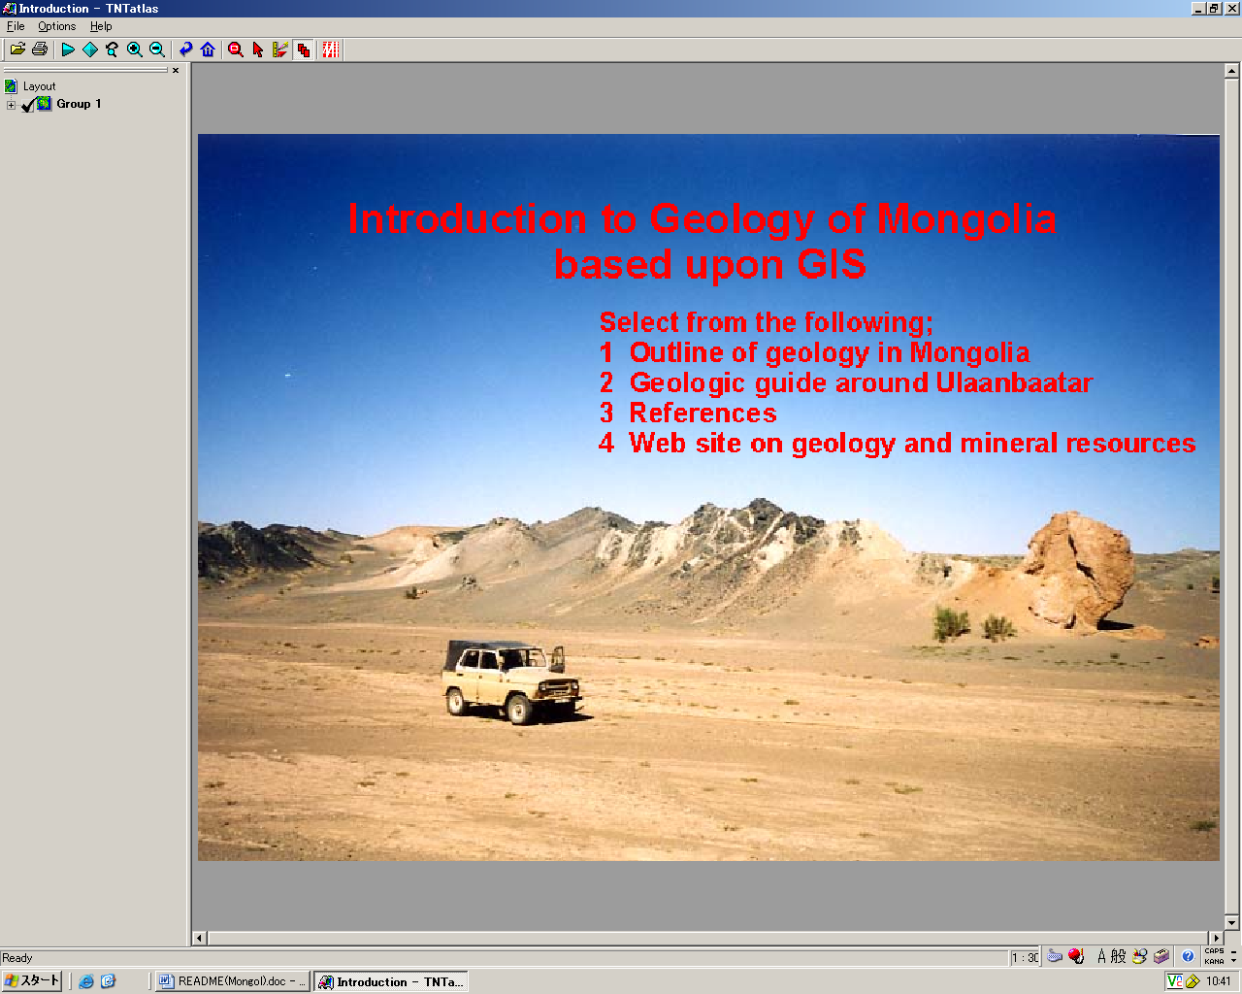
For example, when “Geological guide around Ulaanbaatar” is selected, the following menu is shown.

Geological map
Explanation text
Guide map for excursion
Useful website

(3)Getting more information
For example, if you select “Guide map for excursion”, you see the map showing excursion points. Text or photo will be shown from any point. Previous button and Home button are sometimes used.

(Previous)(Home)
||
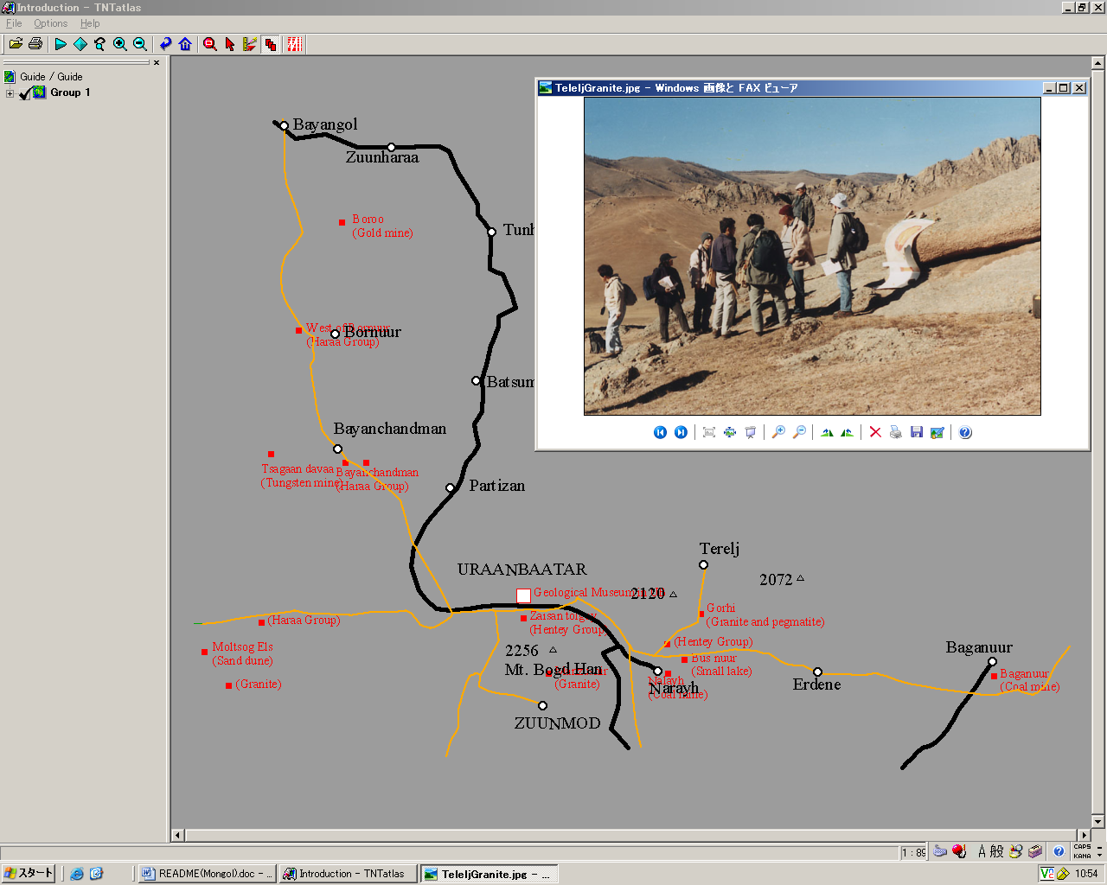
(4) Other functions
Changing size of figure area
(+): for larger figure
(-): for smaller figure
Lozenge: full size figure

Geo tool box (button third from right)
Using this tool, distance and direction between two points are measured. Finding the area of some part is also possible.
(Geo tool box)
|
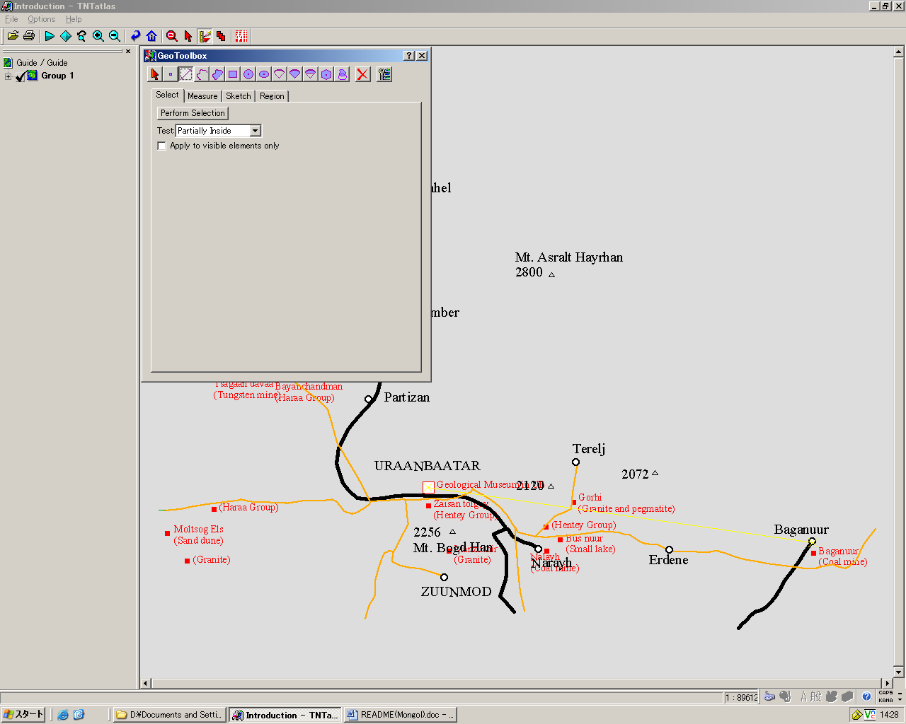

Changing the background color: Options / Preferences / select color

File Option Help
Preferences

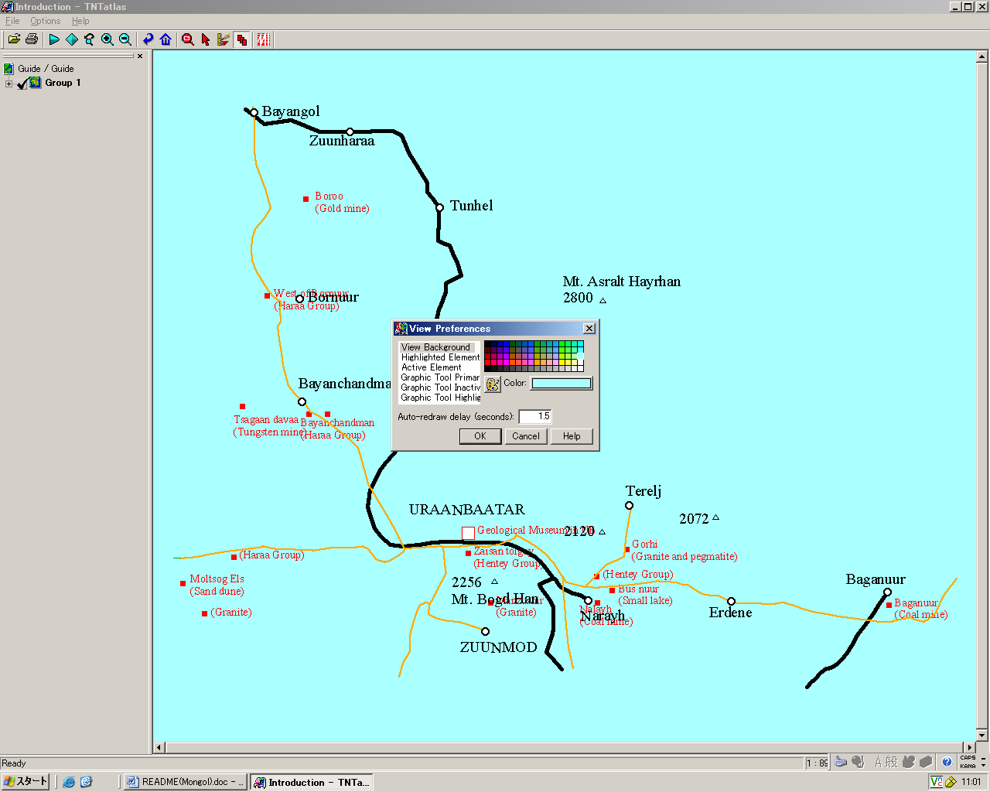

(5) Exit
File / Exit

